**Byng Boys 01** at Bartle Road Tuesday 29th March 2016

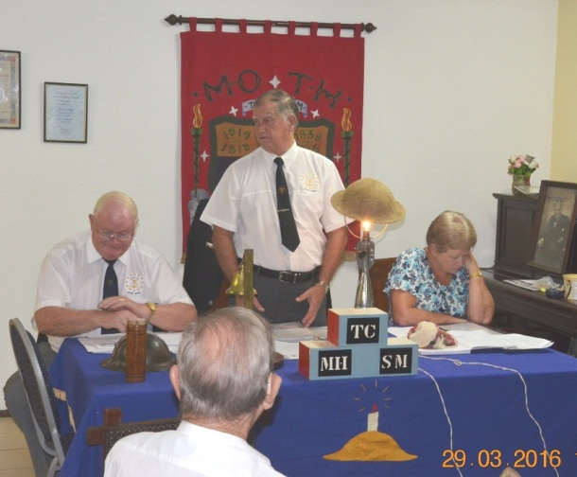

***23 Moth, 10 Apologies,***

***23 Visitors, 1 Raid***

***1 Resignation***

***Photos by Peter Shattock***

Adj Brian Foster, Old Bill Clive Christensen, Paybill Jenny Christensen

Wyn Wykers wins the bottle of wine. With Guillemtte Grutzmacher looking on (of Edwin Swales)

Bryan Bowes wins the Byng Boys raffle, (each member places some ‘goodie’ in the box which is raffled off)

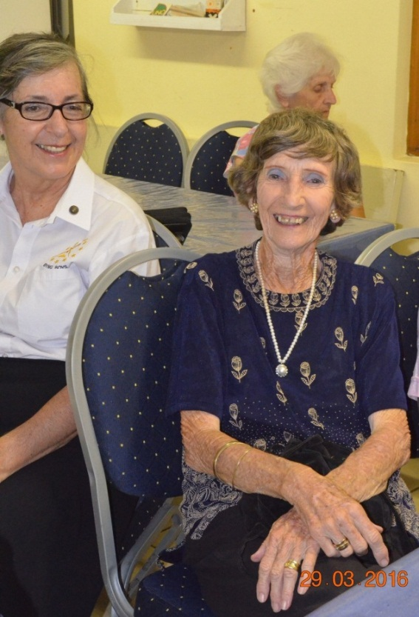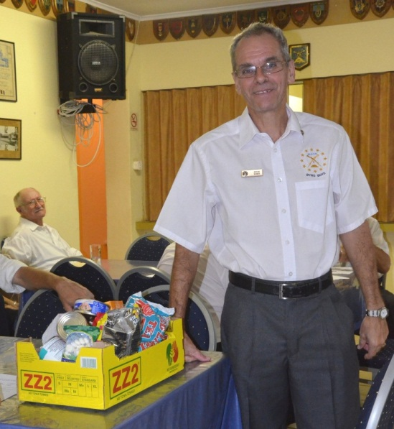

**Byng Boys 02** at Bartle Road Tuesday 29th March 2016

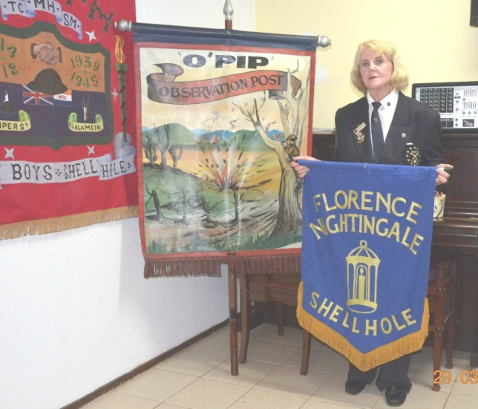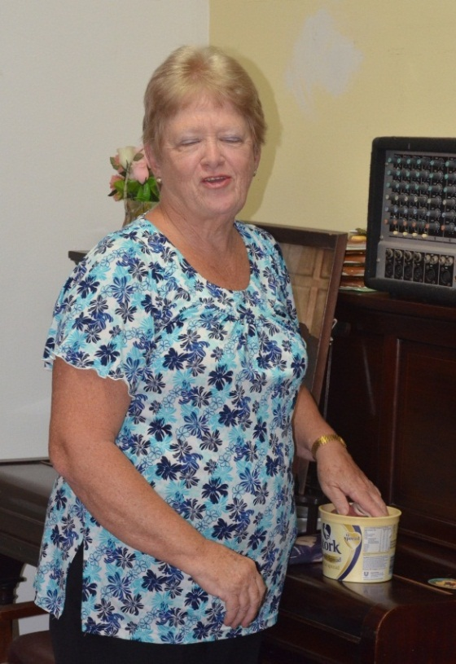

Joan Hayfield, was with O’Pip Shellhole and then joined Florence Nightingale to avoid it closing down for lack of membership. O’Pip & Florence Nightingale have amalgamated And now meet at Bartle Road Moth cottage hall.

Oh My Gosh, with closed eyes, Jenny the Paybill has won the chicken in the raffle ! !

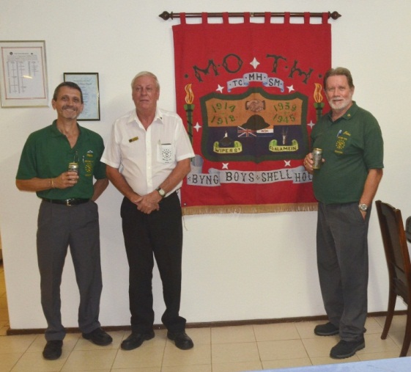

**Better ‘Ole Shellhole RAIDS Byng Boys**

Skippy Michell, Erich Hendricks The War Correspondent